**Logistic Regression:**

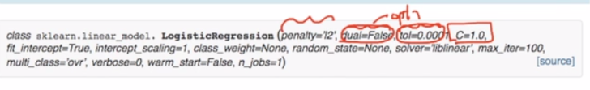

**Penalty**: which regularization to be performed l1 or l2.

**Dual, tol**: is used in optimization

**C** = 1/lambda used in regularization. Therefore since C is inverse of lambda and as:

If lambda increases model gets underfit, and if decreases model gets overfit.

Therfore if As C increases it should Overfit and as C decreases , it should underfit.

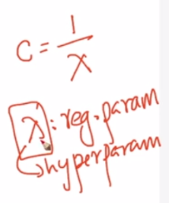

**Fit_intercept**: specifies whether to use interceptor (b) or not in plane eq.

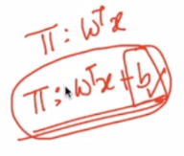

**Class_weight:** It’s used for upsampling for imbalanced data.

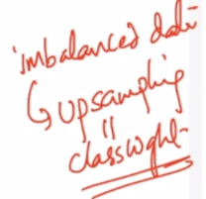 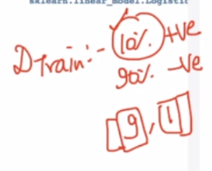

**Multi_class:** it’s to specify if there are more than 2 class labels to be predict.

**GridSearchCV:**

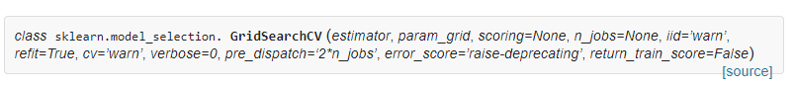

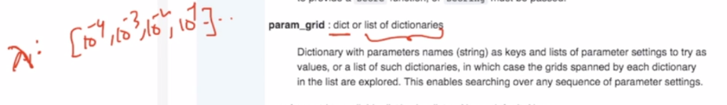

If we are executing models parallel then we may encounter memory error problem, therefore we use pre_dispatch to controls the no. of jobs to be dispatched during parallel execution.

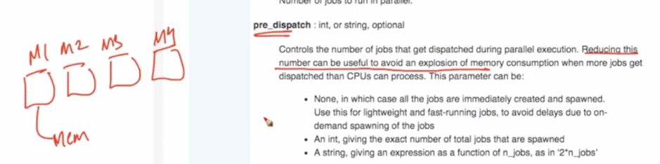

**Error_score:** specify which metri to use: accuracy, f1 score etc.

**RandomizedSearchCV:**

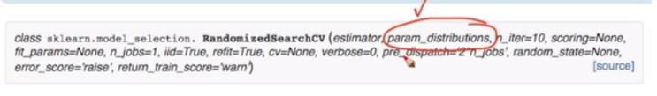

RandomizedSearchCV is similar to GridSearchCV except param_distributions parameter, which expect distribution in which hyperparameter belongs example whether hyperparameter belongs to uniform distribution.

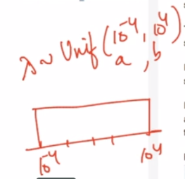

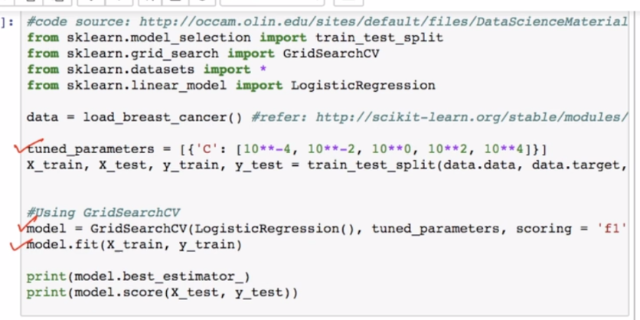

We know that as we increase lambda sparsity of w increases means number of non_zerof will decrease. Below images show example.

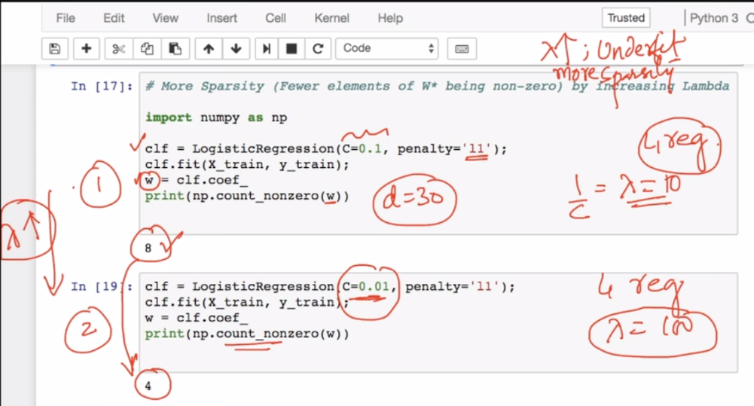

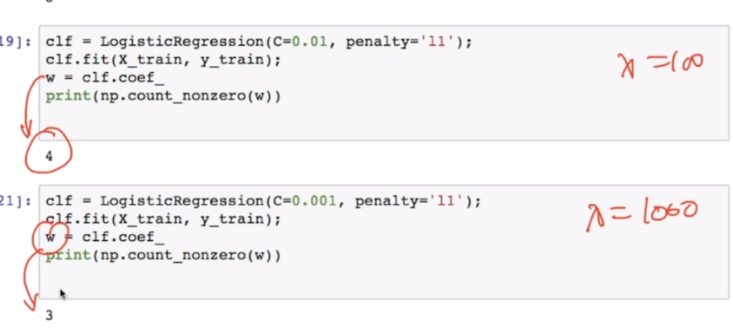

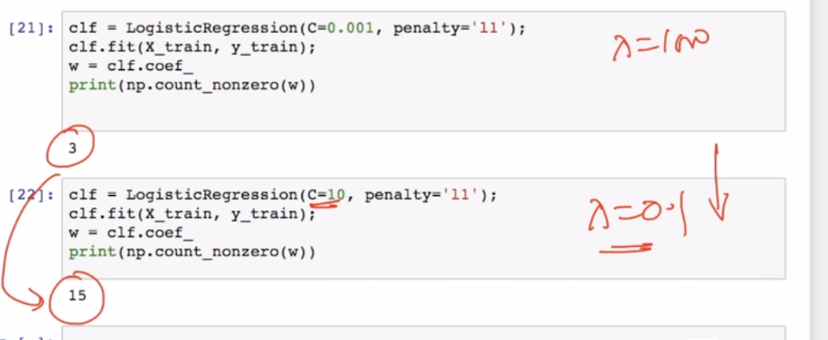

Comments:

